**Written skills in Arbitration**

**Preparation**

1. **Memorials**

* ***Canfor* *Corporation v. The Government of the United States (UNCITRAL)*: (i) Notice of Arbitration, July 9, 2002; (ii) Objections to Jurisdiction, October 16, 2003; and, (iii) Reply Memorial in response to Objections to Jurisdiction, May 14, 2004**

**The Claimant, CME** **Czech Republic B.V., is a corporation** organized under the laws of the Netherlands. The **Respondent, the Czech Republic,** is a sovereign State, represented in these proceedings by its Ministry of Finance.

CME Czech Republic B.V. (CME) initiated these arbitration proceedings on February 22, 2000 by notice of arbitration against the Czech Republic pursuant to Art. 3 of the Arbitration Rules of the United Nations Commission on International Trade Law (UNCITRAL).

CME claims that 􏰁NTS, the most successful Czech private broadcasting station opera- tor with annual net income of roughly USD 30 million, has been commercially destroyed by the actions and omissions attributed to the Media Council, an organ of the Czech Republic

CME claims, inter alia, that a signed merger and acquisition agreement between CME’s interim parent company and the Scandinavian broadcaster and investor Scandinavian Broadcasting System (“SBS”) was vitiated by these actions and omissions of the Media Council. CME accordingly suffered damage of more than USD 500 million, which was the value allocated by that agreement and by the joint venture partners to 􏰁NTS in 1999 before the disruption of the legal and commercial status of 􏰁NTS as a consequence of the Media Council’s actions and omissions.  CME claims that the Media Council, in breach of the Treaty, in 1996 coerced CME into amending the MoA thereby forcing CNTS to give up the exclusive right of the “use“ of the broadcasting license and that the Media Council in 1999 in collusion with Dr. Zelezny lent its support to the destruction of CNTS’ business.

The Czech Republic strongly disputes this contention and the purported underlying facts, maintaining that, inter alia, the loss of investment (if any) is the consequence of commercial failures and misjudgments of CME and, in any event, that CME’s claim is part of a commercial dispute between CNTS and Dr. Zelezny, for which the protection of the Treaty is not available.

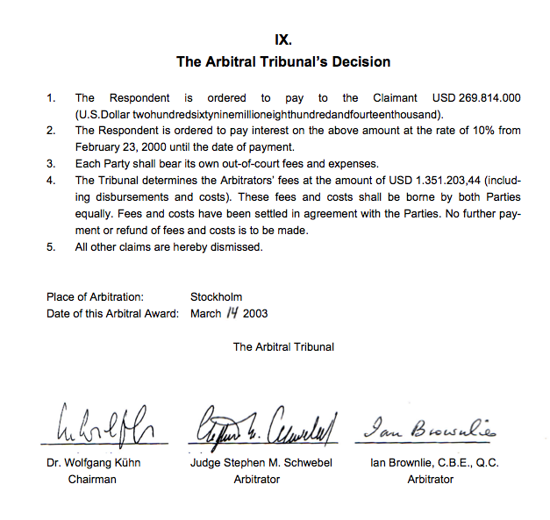

* **Example of a procedural order setting out the applicable procedural rules: (i) Procedural Order No. 1, September 10, 2012 in *St Marys VCNA, LLC v. Government of Canada (UNCITRAL)***

“***Counsel for the Czech Republic have requested us to prepare an opinion*** *in connexion with the proceedings before the Tribunal* ***for the quantum phase of the arbitration****.*

*Our opinion is directed at three major areas which are relevant in the quantum stage of the arbitration proceedings.*

* *The first of these concerns the principle of res judicata in relation to the parallel UNCITRAL arbitration proceedings that ended with the Final Award of 3 September 2001.*
* *The second concerns the Tribunal’s duty to apply the proper law, in particular its duty to apply the law of the Czech Republic.*
* *The third concerns the Tribunal’s use of a theory of joint tortfeasors that has no foundation in international law.*

*In preparing the opinion, August Reinisch has drafted the section dealing with res judicata. Professor Philippe Sands has supplied valuable information on that section. Christoph Schreuer has drafted the section dealing with the duty to apply the proper law. With regard to the section on joint tortfeasors, we were greatly assisted by Dr. Stephan Wittich, an experienced specialist in the field of State responsibility. Despite this division of labour in the opinion's drafting, we have closely cooperated in its overall preparation. Therefore, we are jointly responsible for the opinion as a whole.*

*We have appended statements of our qualifications at the end of this opinion*”.

The report states : goes obviously in the direction of the Czech Republic : Under the general international law of State responsibility, neither the conduct of CET 21 nor that of Dr. Železný may be attributed to the Czech Republic

Followed by : Bibliography and authors’ resumes

* **Bryan A. Garner, LEGAL WRITING IN PLAIN ENGLISH 144 (2001)**

**Likes**

* Brevity
* Clarity
* Logical flow
* Clear issues
* Interesting writing
* Fluidity
* Informative headings
* Clean overall appearance
* Structured paragraphs
* Directness
* Issue & answer in first paragraph
* Practical writing
* Trustworthiness
* Succinctness
* Flowing prose; good transitions
* Clear divisions of thought
* Explanations Accuracy
* Honest, sincere writing
* Supporting rationale
* No footnotes
* Decisiveness
* Originality in presenting ideas
* Concise sentences
* Clear, concise statement of facts
* Outline style
* Short words
* Clear conclusions
* Conveying a sense of justice
* Instant clarity
* Storytelling
* Short, to-the-point style
* Simple sentences
* Clever phrases
* Well-put phrases
* Inspiring confidence about precise questions presented
* Understandable language
* Common sense Immediate identification of issues
* Logical organization
* Entertainment
* Footnotes for string citations
* Comprehensiveness
* Complex ideas stated simply & directly
* Footnotes properly and sparingly used
* Civil tone

1. **Witness Statements and Legal Opinions**

* ***Pac Rim Cayman LLC v. The Republic of El Salvador* (ICSID Case No. ARB/09/12): (i) Decision on the Respondent’s Jurisdictional Objections, June 1, 2012; (ii) Witness Statement of Catherine McLeod-Seltzer, December 31, 2010; and, (iii) Witness Statement of Thomas C. Shrake, December 31, 2010**
* ***CME Czech Republic B.V. (The Netherlands) v. The Czech Republic* (UNCITRAL): (i) Award, March 14, 2003; and, (ii) Legal Opinion of Professor Christoph Schreuer and Professor August Reinisch, June 20, 2002**

1. **Document Production**

* ***Railroad Development Corporation v. The Republic of Guatemala* (ICSID Case No. ARB/07/23): The Republic of *Guatemala’s* Requests for the Production of Documents**
* ***Biwater Gauff (Tanzania) Ltd. v. United Republic of Tanzania* (ICSID Case No. ARB/05/22): Procedural Order No. 2, May 2006**

**Arbitration Rule 34: document production**

**The Arbitral tribunal decision:**

The Arbitral Tribunal notes that the Respondent’s identification of, and articulation of, “public interest immunity” as a doctrine rests upon the national law of Tanzania, and in particular (a) article 54(5) of the Tanzanian Constitution (which prohibits disclosure of any information relating to any advice that the President has received or may receive from the Cabinet) and (b) section 132 of the Tanzanian Evidence Act 1967 (which codifies what was formally known in England as “Crown privilege” and applies to unpublished official records and communications received by a public officer whose disclosure would be prejudicial to the public interest). The Respondent notes that similar doctrines are accepted in other national legal systems. However, and importantly, no equivalent doctrine has been identified as a matter of public international law, or as part of the ICSID regime.

As far as article 54(5) is concerned, the Arbitral Tribunal notes that strictly interpreted, this article does not cover all Cabinet papers but only those which specifically relate to advice for the President. Moreover, article 54(5) prohibits inquiries by “any court”, a term which is defined in the Tanzanian Constitution as any court having jurisdiction in the Republic of Tanzania. It may therefore be argued that this particular prohibition, by its own terms, does not apply to an ICSID Arbitral Tribunal.

More fundamentally, however, the nature of this dispute resolution process is entirely different from a national court process. This is an international tribunal, governed by an international convention, which is mandated to enquire into the conduct and responsibility of a State in light of its international treaty and customary international law obligations. It is hardly conceivable that, in this setting, a State might invoke domestic notions of public interest and policy relating to the operations of its own Government as a basis to object to the production of documents which are relevant to determine whether the State has violated its international obligations and whether, therefore, its international responsibility is engaged. This is certainly not the context in which the doctrine of “public interest immunity” was developed. The doctrine is not a general principle of law as understood for the purposes of article 38 (1)(c) of the Statute of the International Court of Justice. Neither is it provided for in the ICSID Convention or the ICSID Arbitration Rules (which endow ICSID Tribunals with broad powers to order the production of documents).

Further, if a State were permitted to deploy its own national law in this way, it would, in effect, be avoiding its obligation to produce documents in so far as called upon to do so by this Tribunal. This, in itself, is an international legal obligation arising from the State’s consent by way of the BIT to ICSID arbitration. It may also thereby stifle the evaluation of its own conduct and responsibility. As such, this would be to undermine the well established rule that no State may have recourse to its own internal law as a means of avoiding its international responsibilities. This principle finds expression in Article 27 of the Vienna Convention on the Law of Treaties 1969, as well as numerous other international decisions and commentaries (see e.g. Oppenheim’s International Law (9th Ed, Vol 1, Jennings & Watts ed.), at pp. 84-85).

Moreover, accepting Respondent’s theory would create an imbalance between the parties, which the Tribunal considers unacceptable. It is indeed one of the most fundamental principles of international arbitration that the parties should be treated with equality.

The Arbitral Tribunal considers that the only ground which might justify a refusal by the Republic to produce documents to this Tribunal is the protection of privileged or politically sensitive information, including State secrets, as pointed out by the Arbitral Tribunal in Pope and Talbot, Inc. v. Government of Canada, Ruling on Claim of Crown Privilege dated 6 September 2000 (2005) 7 ICSID Rep. 99, para. 1.4, and restated in article 9(2)(f) of the IBA Rules of Evidence (“The Arbitral Tribunal shall ... exclude from evidence or production any document ... for any of the following reasons : ... (f) grounds of special political or institutional sensitivity (including evidence that has been classified as secret by a Government or a public international institution) that the Arbitral Tribunal determines to be compelling ...”).

In conclusion, the Arbitral Tribunal decides that the public interest immunity exception invoked by the Respondent is not a valid objection to the production of documents requested by the Claimant. However, to the extent that some of the documents whose production will be ordered might be considered politically sensitive, as for example containing State secrets, the Respondent should immediately refer the matter to the Arbitral Tribunal. More precisely, the Respondent should identify the relevant document(s) and indicate the reasons why in conformity with the above mentioned principles the document concerned should be withheld, or disclosed subject to specific restrictions in order to preserve confidentiality. Any dispute will be finally decided by the Arbitral Tribunal. The Tribunal emphasizes in this respect that the fact that a document could be adverse to the position of the Respondent in this arbitration is not sufficient to qualify the document as politically sensitive.

All decisions made below are without prejudice to this direction.

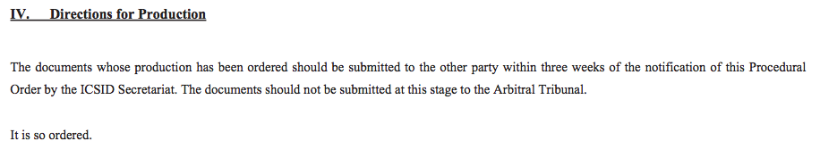

* **The IBA Rules on the Taking of Evidence in International Arbitration, May 2010**